Name-Veman C ritti
Week 8

Dining Philosophers Problem—
#include <stdio.h>
#include <pthread.h>
#include <semaphore.h>
#include <unistd.h>

#define N 5

#define THINKING 0
#define HUNGRY 1
#define EATING 2

int state[N];

sem_t mutex;
sem_t s[N];

void test(int i) {
if (state[i] == HUNGRY &&
state[(i + 4) % N] != EATING &&
state[(i + 1) % N] != EATING) {

state[i] = EATING;
printf("philosopher %d picks chopsticks:%d and %d\n",i,i,(i+4)%N);
sem_post(&s[i]);
}
}

void take_forks(int i) {
sem_wait(&mutex);

state[i] = HUNGRY;
printf("Philosopher %d is HUNGRY\n", i);

test(i);

sem_post(&mutex);

sem_wait(&s[i]);
}

void put_forks(int i) {
sem_wait(&mutex);

state[i] = THINKING;
printf("Philosopher %d is THINKING\n", i);

test((i + 4) % N);
test((i + 1) % N);

sem_post(&mutex);
}

void* philosopher(void* num) {
int i = *(int*)num;

while (1) {
sleep(1);

take_forks(i);

printf("Philosopher %d is EATING\n", i);
sleep(1);

put_forks(i);
}
}

int main() {
pthread_t thread_id[N];
int phil[N];

sem_init(&mutex, 0, 1);

for (int i = 0; i < N; i++) {
sem_init(&s[i], 0, 0);
state[i] = THINKING;
}

for (int i = 0; i < N; i++) {
phil[i] = i;
pthread_create(&thread_id[i], NULL, philosopher, &phil[i]);
}

for (int i = 0; i < N; i++)
pthread_join(thread_id[i], NULL);

return 0;
}

Output--
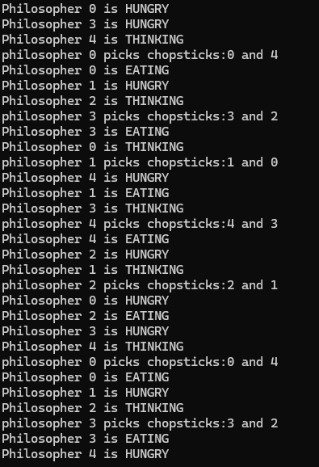

DeadLock detection algorithm—
Code-
#include <stdio.h>
#include <stdbool.h>

int main() {
int n, m;

printf("Enter number of processes: ");
scanf("%d", &n);

printf("Enter number of resources: ");
scanf("%d", &m);

int allocation[n][m], request[n][m], available[m];

printf("\nEnter Allocation Matrix:\n");
for(int i = 0; i < n; i++) {
for(int j = 0; j < m; j++) {
scanf("%d", &allocation[i][j]);
}
}

printf("\nEnter Request Matrix:\n");
for(int i = 0; i < n; i++) {
for(int j = 0; j < m; j++) {
scanf("%d", &request[i][j]);
}
}

printf("\nEnter Available Resources:\n");
for(int j = 0; j < m; j++) {
scanf("%d", &available[j]);
}

bool finish[n];
for(int i = 0; i < n; i++) {
finish[i] = false;
}

int work[m];
for(int j = 0; j < m; j++) {
work[j] = available[j];
}

int count = 0;

while(count < n) {
bool found = false;

for(int i = 0; i < n; i++) {
if(!finish[i]) {
int j;
for(j = 0; j < m; j++) {
if(request[i][j] > work[j]) {
break;
}
}

if(j == m) {
for(int k = 0; k < m; k++) {
work[k] += allocation[i][k];
}

finish[i] = true;
found = true;
count++;
}
}
}
if(!found) {
break;
}
}
bool deadlock = false;
printf("\nProcesses in Deadlock:\n");

for(int i = 0; i < n; i++) {
if(!finish[i]) {
printf("P%d ", i);
deadlock = true;
}
}

if(!deadlock) {
printf("No Deadlock Detected\n");
}

return 0;
}
Output--
